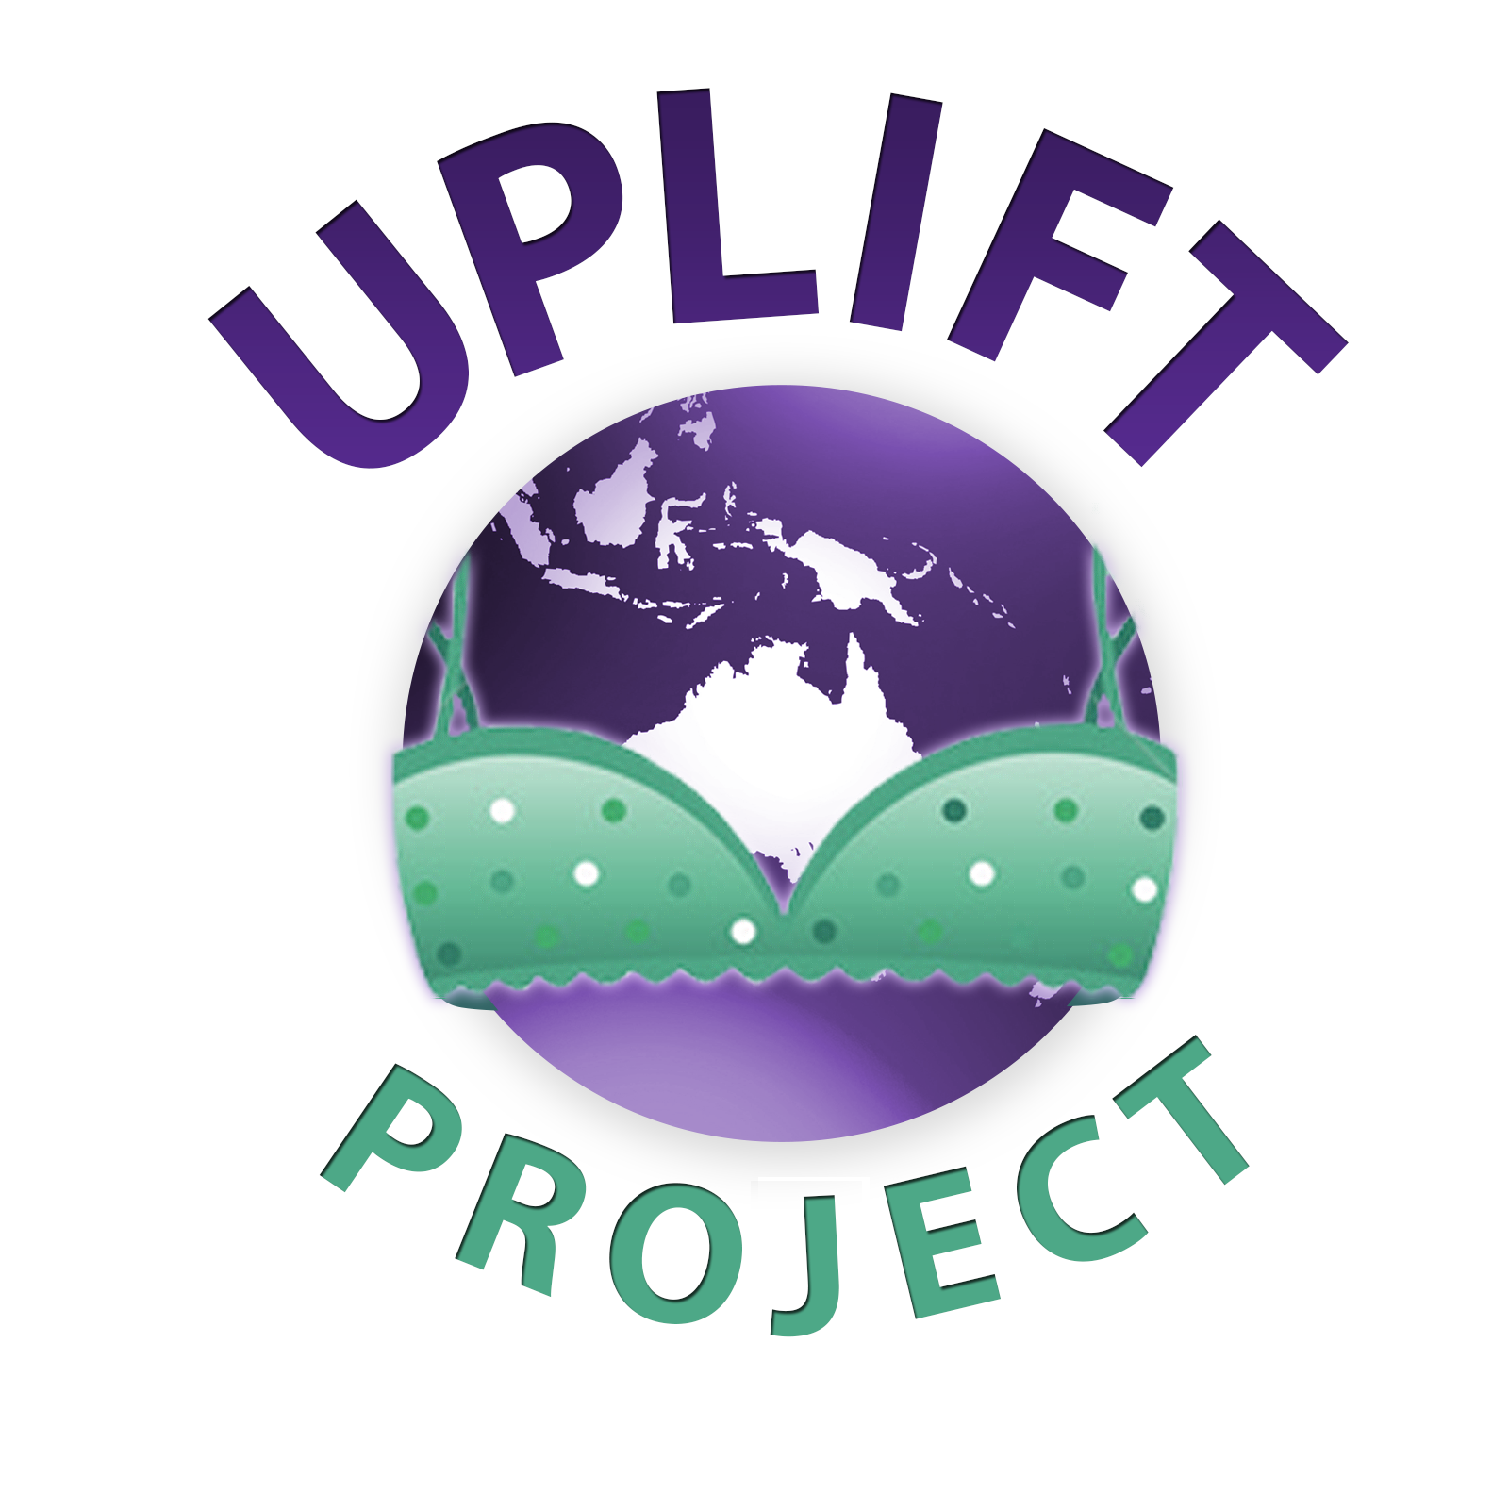
Many women live without one
RECYCLE YOUR BRA

In many regions second hand bras are cheap enough, but rarely available. A new bra, if available at all, can cost 10-30 hour’s wages.
Nursing mums everywhere leak. Bras allow the dignity of a dry shirt, and the comfort of support. Women and girls prefer to have a bra for social and work situations. A mastectomy bra offers privacy about the problem. Bras control breast swing when women bend to ground level to farm or cook.
In humid climates rashes, fungal infections and abscesses occur between the breast and the chest wall. Bras help by allowing air flow.
A girl with no underpants does not go to school when menstruating.
Since 2005 Uplift Project has sent over 2 million bras to 21 countries across the Pacific, Asia, and Africa.
Uplift only sends bras when we have requests from local women’s groups.
Collections occurring in:
All Australian states and territories
Christchurch
Auckland

We’ve supplied to:
Fiji
PNG
Philippines
Solomon Islands
Cook Islands,
Bali
Cambodia
Vanuatu
Sri Lanka
NZ
Botswana
Kiribati
Australia
Pakistan
Kenya

We Collect
Second hand:

DROP OFF BRAS HERE
8-16 A-D cup, good condition
18+ any conditions
E cup plus, any size, any condition.
Nursing bras/crop tops, ALL
Mastectomy bras and prostheses
Swimwear.

New:
The bra she receives from Uplift Project
is often the only bra that woman owns.
Underpants
Any of the above

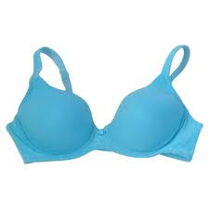

www.upliftbras.org

